**Online**

**Examination**

**System**

**P**



**Acknowledgement**

I express my sincere thanks to my teacher Sir Zeeshan for providing me the opportunity to perform my project.

A project cannot be created entirely by an individual. I got help from many people and their Contribution has been valuable. The completion of this project is due to the interest and persuasion of my teacher.

My sincere thanks to once again Mr. Zeeshan Ali(my teacher) Mr. Nouman Farooq(my teacher) and Saim Farooq(my classmate).

I would like to thank all other individuals who helped me directly or indirectly.

**Summary**

Now, internet is used very much in our day to day life. There is tremendous increase of using internet for education purpose. The eExamination (online examination system) is easy and full featured, web application where students can give or take examination. Administrator can set different examination and questions for registered students and members. This examination system provides complete functionality to store results of students and members. The Administrator can set exam name, select exam and assign questions to it and also manage the members.

**Table of Contents**

1. **Introduction………………………………………………………….. 5**

1.1 Problem definition….......…………………………………………..6

1.2 Objective…………………………………………………………...6

* 1. Purpose..…………………………………………………………...6
  2. Brief Introduction………..………………………………………...6
  3. Existing Systems…………………………………………………...7

**2. Requirement Analysis…..……………………………………………8**

2.1 User Requirement Analysis…...…………………………………..9

3. **Proposed System……………………………………………………….10**

3.1 Data Flow Diagram………………………………………………….11

3.2 Entity relationship Diagram………………………………………..12

4. **Design Details…………………………………………………………...13**

4.1 Function of System……………………….……………….…………...14

4.2 Administrative Aspect………………………………………….……...14

4.3 Student Aspect…………………………………………….…………..14

4.4 Working of System…………………………………………………....15

4.5 Runtime Pics………………………………………………………….15

4.6 Conclusion……..……………………………………………………..20

CHAPTER 1:

Introduction

**Problem definition:**

Online Examination is very helpful to users. The aim of this project is to provide quick, immediate and easy way to appear the exam. It can provide special advantages to the students/applicants. The online examination system can automatically add the marks allocated in each question to determine the total mark for the questions

Online Examination System is very useful for Educational Institute to prepare an exam, save the time that will take to check the paper and prepare mark sheets. It will help the Institute to test students and develop their skills.

**Objective:**

The general objective of my system is to change the current manual system into computerized zone.

**Purpose:**

The students or members willing to test or share their knowledge among others. The eExamination System is made to permit them to take and give online examination and maintaining master information about the members and generating various reports of test.

**Brief Introduction to design:**

The eExamination System will allow the users to take and give online examination. It maintains the information about its users and also generates various reports of test that are taken and given by the members.. The main users of the project are Student or Member and system Administrator. From an end-user perspective, the eExamination System Project consists of two functional elements: enhanced Member modules(user) for registration, giving examination, manage profile. And Administration module for Mange members, examination, question bank and view the reports.

**Existing Systems:**

The traditional way of taking examination is that all the students have to be gathered at one place physically. The examiner is restricted to be present, while students are giving the examination. Results of students are stored on papers. Examiner have to take care of that paper. If a paper is required to recheck then you have to search that paper through bundles of paper which is very inefficient, costly and time consuming way of taking and maintaining the examination system.

There are existing systems of examination let the users to give the examination on the internet too. In those systems the members are only allowed to give the exam and view their results. In this system users can also set exams and add questions to their exams that exam will be available to all. It is taken care that user/member can only make changes to the exams set by him. He has no access to the other exams not set by him. The only one Administrator can set, view and update all the exams and all the users.

CHAPTER 2:

Requirement Analysis

**User Requirements Analysis:**

This project is a web application that is developed in PHP having MYSQL as back end. For the development of this web application we are required to store the information about

**Users**, users are further divided into three categories

1. The users who can give exams only
2. The users who can give and takes examination. These users can manage their exams like adding exam and adding questions to it. It is taken care that users can only access to those exams added by him for the update purpose.
3. Sophisticated user who can manage all the exams add by any naïve users or by himself

Moreover, there is users/Members ‘s setting, from here the admin can change the settings of different users. User can also Edit his **profile** to change the password or its name.

**Examination** of different subject is stored in this table, once user is logged in, he can start the exam if he is an end user or he can add examination and questions to it. Activities of all the users is monitored b Administrator.

**Question Bank** is required to store the questions of different subject. This question ‘s table stores the questions related to a particular subject.

**Result**  To store the results of users we required a table results. This table stores and shows the result of different users and also give information about the subject in which user has passed or failed.

Once the user starts the examination then its marks are automatically calculated and added to the **result** at the end of examination information about right answers and the percentage of user in that particular subject is shown too.

**Feedback**  To know whether my system is fulfilling the user requirements, feed back from the users is also required. System facilitate the users to send their feedback.

CHAPTER 3

Proposed System

**Data Flow Diagram:**

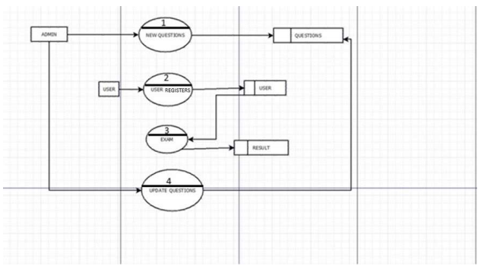

**Entity Relationship Diagram**

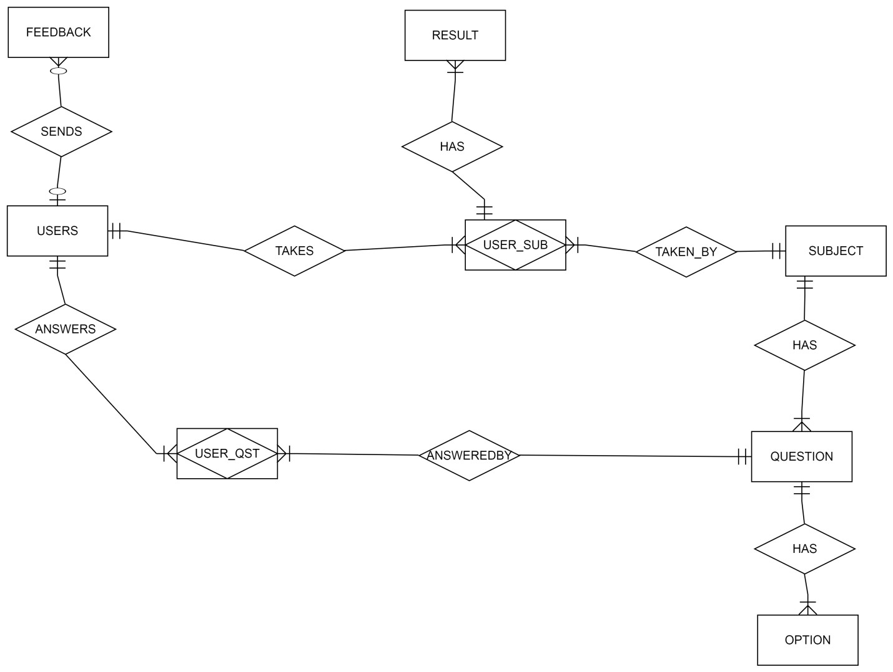**Defining the Relations**

* A user takes one or more subjects for examination and a subject is taken by one or many users (Many to Many)
* A Subject has many Questions(one to many)
* A question has many options(one to many)
* User may sends one or many feedbacks(one to many optional)
* A User and Subject has one or many results.

CHAPTER 4

Design Details

**Function of System**

Required software is for conducting online examination and providing results. The system should satisfy the following requirements: User Requirements.

**Administrator Aspect**

1- Logging into the system.

2. Accepting registrations of candidates.

3. Adding/editing/deleting the Subjects.

4. Adding/editing/deleting the questions.

5. Creating Exams.

6. Creating questions.

7. Posting multiple options to respective question.

8. Giving correct answer within the given options.

10.Managing User Privileges and Status

**Student Aspect:**

1. Requesting registration.

2. Logging into the system.

3. Selecting the exam.

4. Appearing for the examination.

5. Reviewing his result.

6- Sending Feedback

**Working of System**

1. Authenticating users based on username and password

2. Recording candidates’ responses to every question of relevant exam.

3. Checking whether the given response is correct or not.

4. Keeping the result of User.

**Runtime Pictures:**

**Homepage**

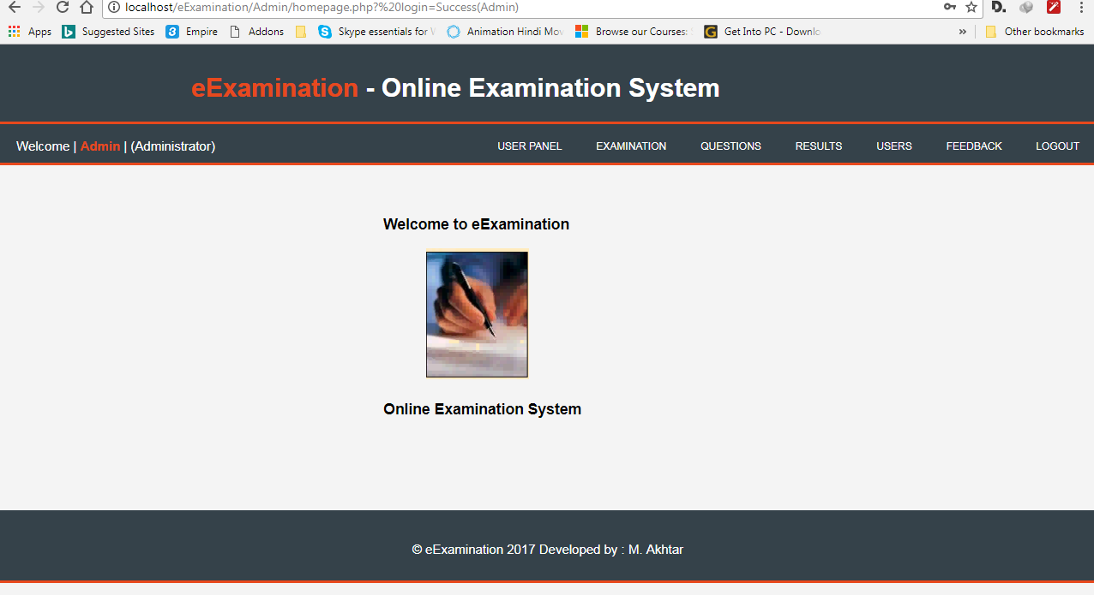this is the home page when admin logs in

**Exam**.

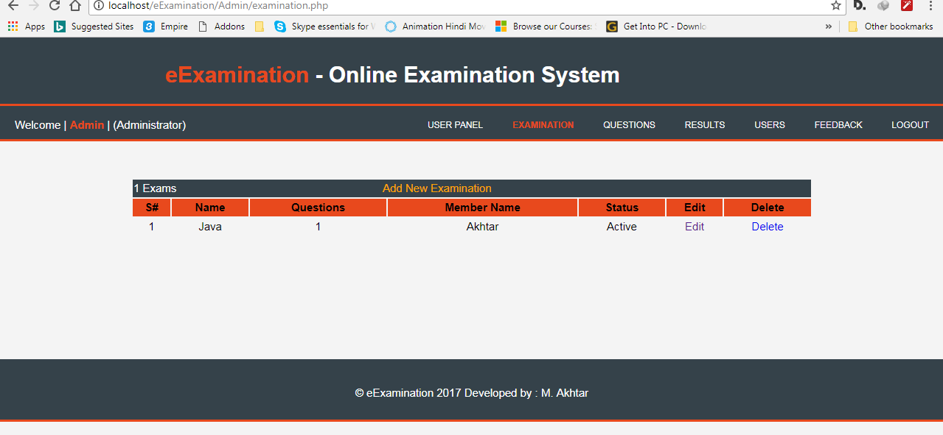 **Questions**:

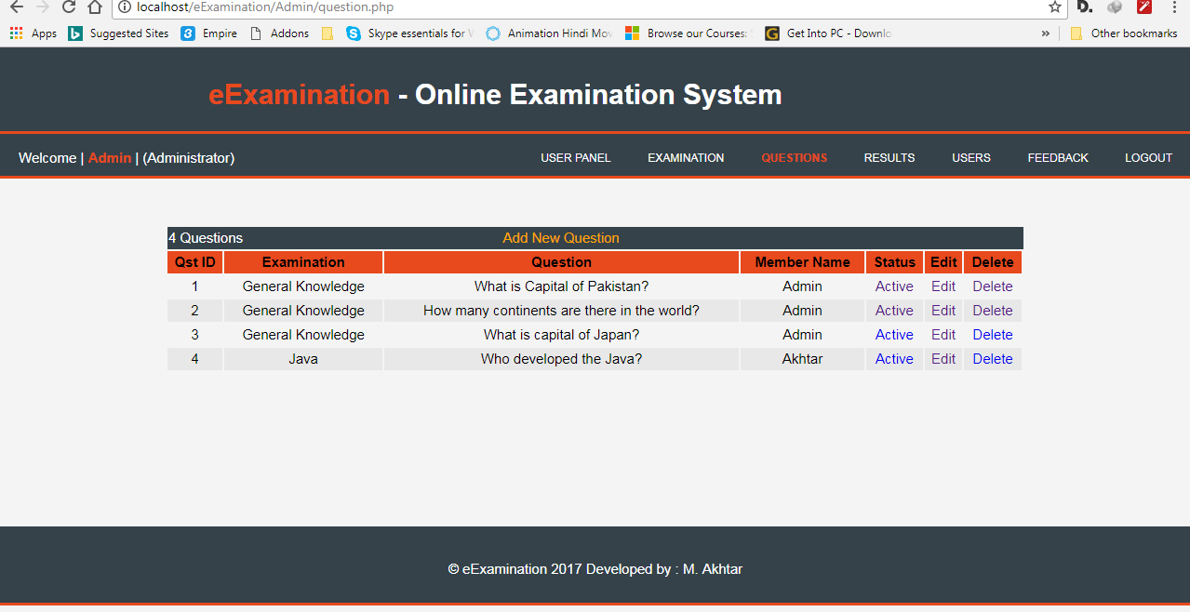

**User Setting**

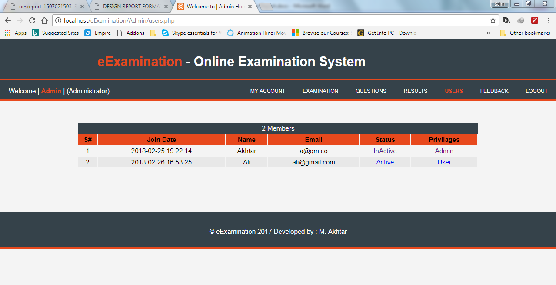

**User Panel**

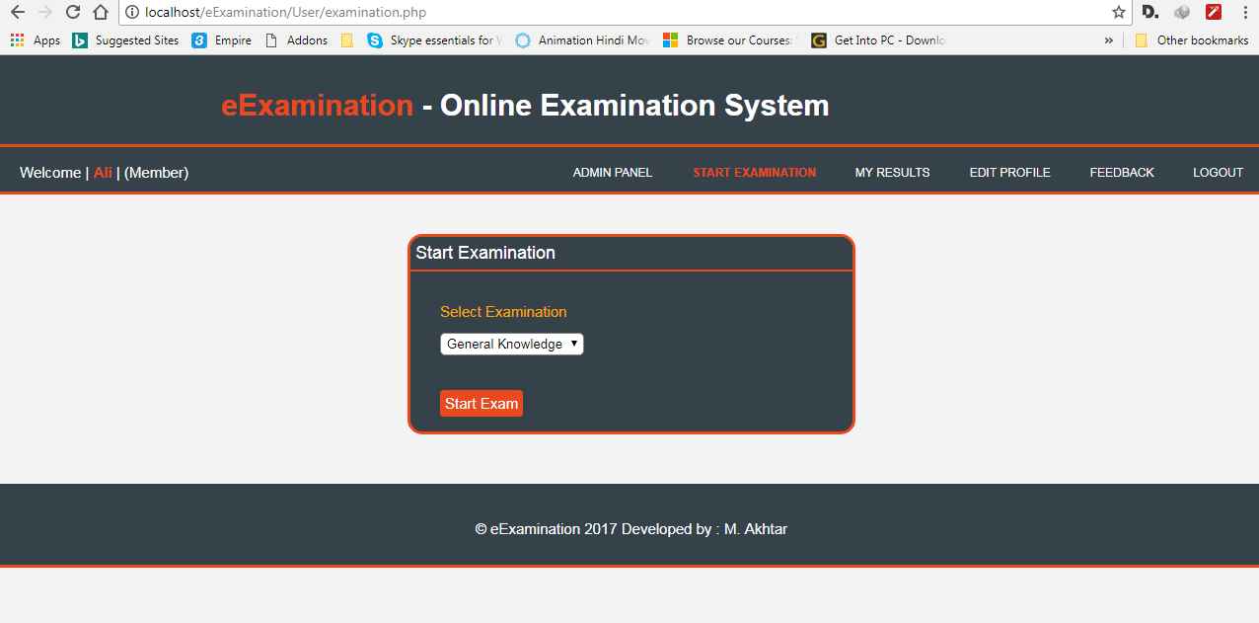

**Exam Started**

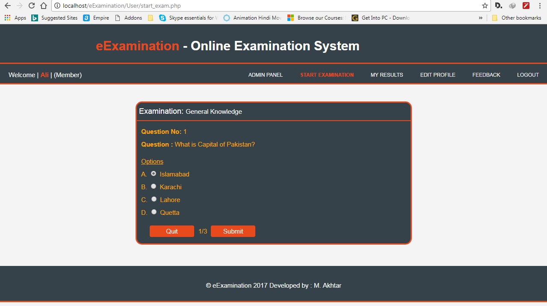

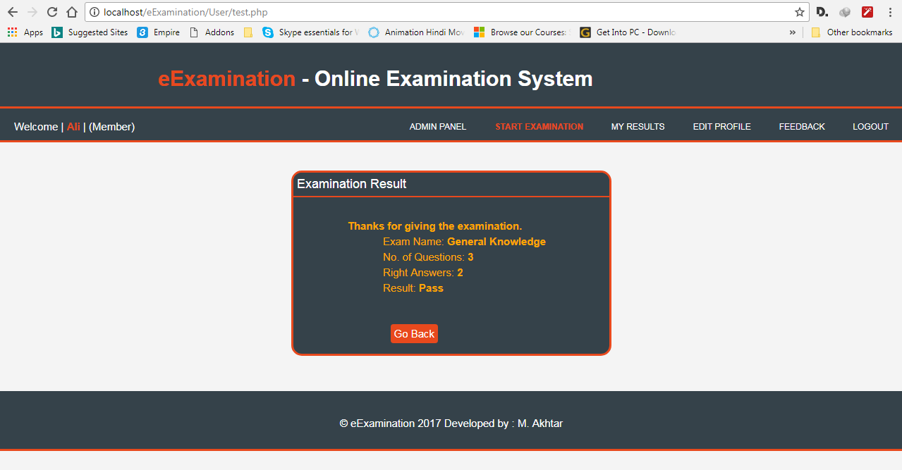

**Results:**

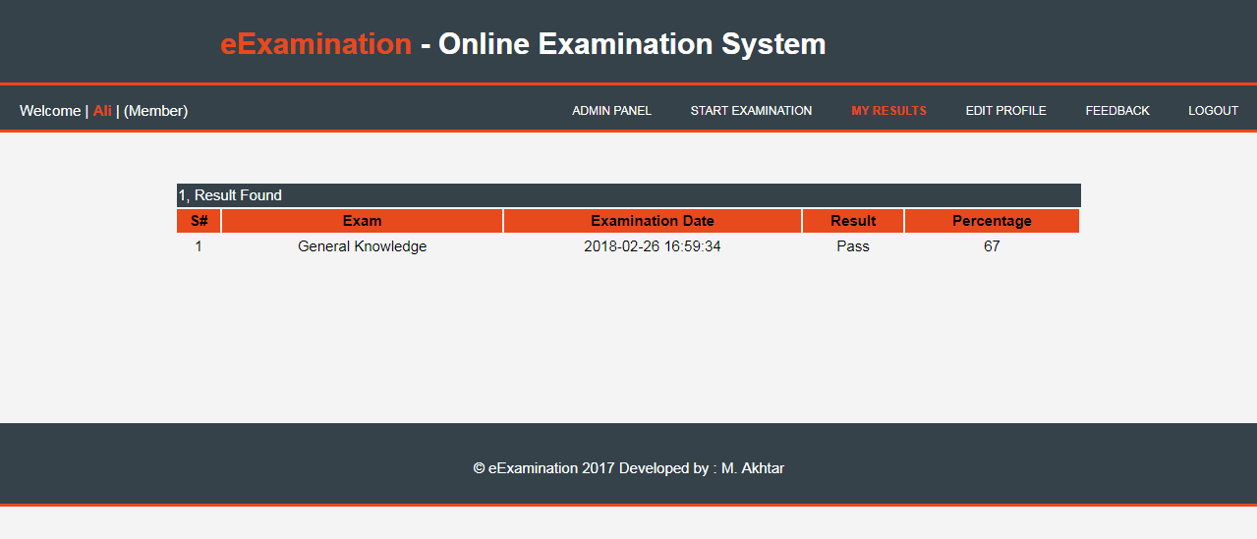

**Feedback**

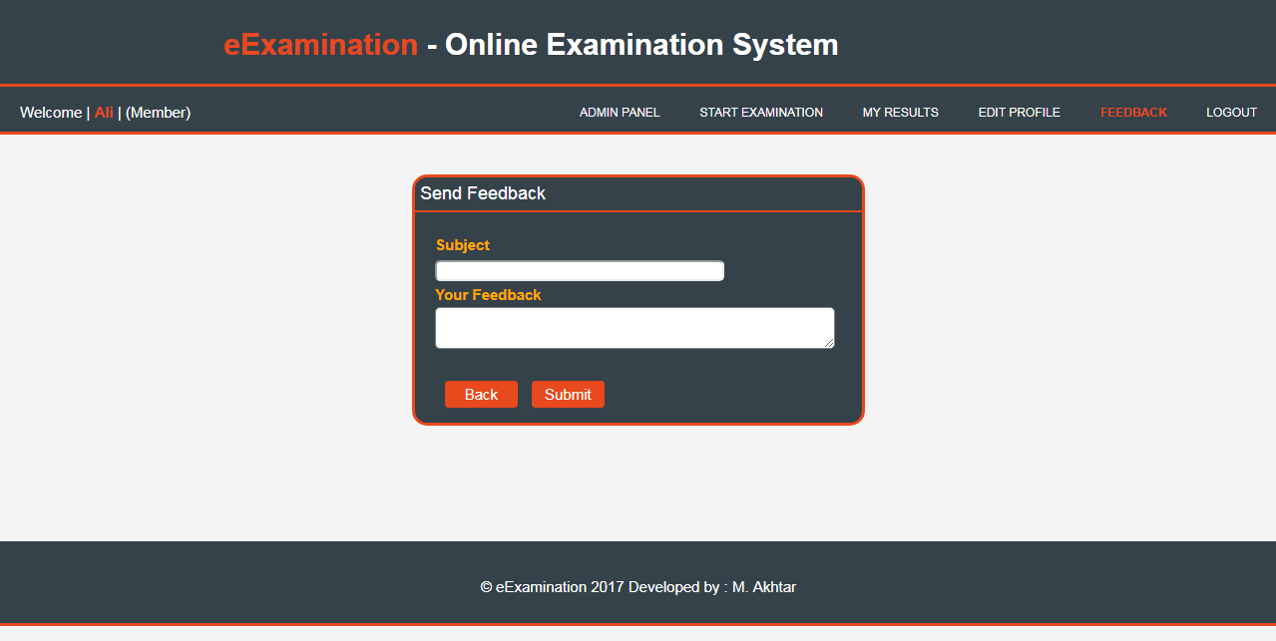

**Conclusions:**

There are existing systems of examination let the users to give the examination on the internet too. In those systems the members are only allowed to give the exam and view their results. In this system users can also set exams and add questions to their exams that exam will be available to all. It is taken care that user/member can only make changes to the exams set by him. He has no access to the other exams not set by him. The only one Administrator can set, view and update all the exams and all the users.

It can be safely concluded that the product is a highly efficient GUI based component. This application is working properly and meeting to all user requirements. This component can be easily plugged in many other systems.